Mrs. Shannon Lindsay
678-594-8104, ext. 056
Shannon.lindsay@cobbk12.org
www.HarrisonTheatre.com

Course Description: This course will examine all aspects of Musical Theatre. Performers will study voice, dance, and acting as part of a full-length musical production. Technicians will study script analysis, design, and production of all technical elements of the play. After-school rehearsals will be required as part of this course. A detailed rehearsal schedule will be made available at the beginning of class.
Admittance to this class is by audition or application only.
Georgia Standards of Excellence - Musical Theatre
Expectations:
- All Company members are expected to attend and be fully prepared with all materials and proper attire for every rehearsal and performance.
- All clothing and footwear should be appropriate for movement and dance. Long hair should be pulled back off your face.
- There will be NO FOOD, DRINKS, or GUM in either the Black Box or the Performing Arts Center. Water breaks will be taken outside the performance spaces. Refillable water bottles should be brought every day.
- All Company members are expected to meet all deadlines according to the timelines given
- All Company members are expected to rehearse or complete work outside of class in order to make the show successful
- Actors and Ensemble Chorus members will be expected to provide their own footwear and Stage Makeup.
- Tech crew members are expected to wear all black, including footwear. Harrison Theatre will provide one long sleeve Tech Crew shirt.
- All classroom materials, including student written material, will be appropriate and refrain from using offensive or suggestive language. It is expected that you respect your audience as well as your fellow actors and technicians.
- All Company members are expected to embrace and exhibit the Theatre Core Values. Everything you need to know about how to behave and what is expected of you in classes and rehearsals can be summed up within these seven Core Values:

Trust: Genuine trust is a necessary component of artistic expression and collaboration
within an ensemble.
Honesty: We intend to be honest, authentic, and sincere in order to build a stronger
ensemble.
Ensemble: We intend to be a strong and supportive ensemble in order to create
meaningful experiences in rehearsals and performances.
Attitude: A positive attitude is necessary to maintain a productive learning
environment.
Talent: We commit to bringing the best of our individual talents to each project.
Respect: When we demonstrate respect for each other, our spaces, and the artistic
process it strengthens our ensemble and results in a positive experience for all.
Excellence: We strive for excellence in everything we do. It is the repetition of
excellence that makes an artist.

Cell Phone policy: Cell phones, headphones, earbuds and other electronic devices should be put away, out of sight, and on silent during class. NO social media apps, video streaming apps or games that are not being used in instruction should be open at any time during the class period. On the rare occasion that a cell phone is needed in class, students will be directed to retrieve them. Any cell phones out during class without permission will be placed in a closed container for the remainder of the class. NOTE: During Rehearsals and Performances Cell Phones will be locked away and kept with the Stage Manager. In case of Emergency, caretakers can call Mrs. Lindsay directly at 678-918-0028.

Scripts/Scores/Sheet Music: All Company Members will receive an official Libretto/Vocal book from Concord Theatrics and may receive additional materials such as Piano/Vocal scores or other sheet music. These materials were purchased by Harrison Theatre for exclusive use in this production. Harrison Theatre will has purchased ONE copy of the Libretto/Vocal book for each ensemble member.

They may be marked in pencil, highlighted, etc. but MUST be returned to Concord. Loss or damage of these books will result in additional costs to Harrison Theatre to order new ones. Because of this, there will be a $15 replacement fee for any loss or damage of any rehearsal materials if you need Harrison Theatre to re-order it for you.

Assessments: Students will receive a daily grade which includes active participation, quizzes, journal and writing assignments, rehearsals, homework, and preparation. Students are expected to keep a well-organized notebook and/or folder throughout the class, which will be collected and reviewed periodically throughout the class. Just a reminder, I do not GIVE grades, YOU EARN THEM! I will make EVERY effort to support you and will accept late work within a reasonable amount of time. PLEASE DO NOT TAKE ADVANTAGE OF MY GRACE AND KINDNESS OR IT WILL NOT BE EXTENDED AGAIN.

Performances and class projects 40%
Daily grades 30%
Tests (open notes) 20%
Final Project/Reflection 10%

Materials:
- Access to a laptop or tablet for online Journals, notes, etc.
- 1-inch, 3-ring Binder or Folder with prongs
- 3 hole punched Loose-leaf paper
- Script/Score & sheet music
- Pencils and blue/black ink pen
- Re-fillable Water Bottle
- *Optional items: Highlighter, Colored pencils, post-it notes

Absences, Participation, & Missed Work:
- Active participation and sharing of your individual talents (even those you don’t know you have yet!) creates a positive attitude and builds a respectful, trusting ensemble. You are expected to take risks, participate each day, and consistently strive for excellence.
- Attendance and participation are signs of respect for yourself and your ensemble. Students should be sitting in their seats, ready to work, when the bell rings. Except in the case of illness or emergency, all absences should be communicated ahead of time. Excessive absences may result in removal from a scene or, in extreme cases, from the production itself.
- It is your responsibility to make up any work you have missed. Late work will be accepted up until the end of the grading period. Missing assignments at the end of the grading period will receive a zero. Students that are absent on days that performances or presentations are due will be expected to present the assignment on the day the student returns to school.
Class Dues: Since this is a production based class and will culminate in performances for the public, there is a production fee of $200 to cover the costs of additional staff, royalties, scripts, musical accompaniment, sets, props, costumes, makeup, some meals, etc. Because of the ever-changing nature of COVID-19 protocols, we have decided to split the fees into 2 payments of $100 each. The first payment is due November 30 and the second is due January. Production fees can be paid through Cheddar Up at: https://musical-cast-and-crew-commitment-form.cheddarup.com or in person by cash or check (no credit cards). Cash and check payments should be in a sealed envelope with the Students Name and “Musical Production Fee” and placed in the grey lock box in the Black Box Theatre.
Communication:
- General information including auditions information, ticket information, and general Harrison Theatre information can be found at the Harrison Theatre website: www.harrisontheatre.com.
- Class communication will be done through CTLS and through Remind. To join the Remind for this class, Cast member should text @mt-cast to 81010 and Crew members should text @mt-crew to 81010. Please make sure all student and family information is up to date.
- Feel free to join the following groups on Remind to get text message updates:
  - For general Harrison Theatre information, text @HTinfo to 81010
  - For Drama Club updates, text @hoyadrclub to 81010
  - For ITS updates (inducted Thespians only!), text @its4996 to 81010
- Many of you will be pushed out of your comfort zone at some point during class. This is encouraged and to be expected, but please always feel free to contact me to talk through any discomfort or challenges you may be having. I may be available to speak with students before or after classes and rehearsals. You can call me at 678-594-8104, ext. 056, but the best policy is to email me at shannon.lindsay@cobbk12.org for an appointment.
Follow us on social media: @hoyatheatre

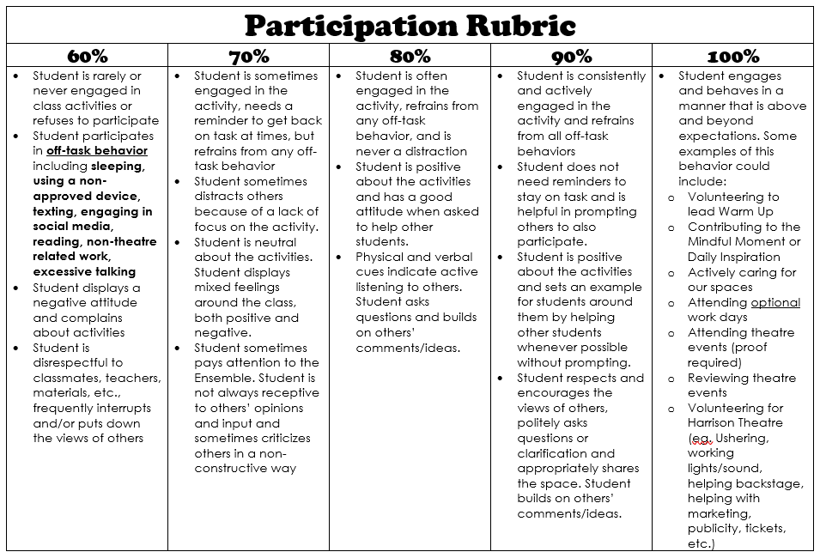

Important Dates
**Please note: The most up to date calendar information is on the Google Calendar which can be find on the Harrison Theatre website: www.harrisontheatre.com**

Nov. 1 M 3:30-7 pm Auditions – Songs & Scenes (sign up for slots)
Nov. 2 T 3:30-7 pm Auditions – Songs & Scenes (sign up for slots)
Nov. 3 W 4:30-7 pm Auditions – Dance Call (ALL)
Tech Applications due @ 10 pm
Nov. 16 T 3:30-5 Music Rehearsal
5-6 Family Info Meeting
Nov. 18 Th 3:30-5 Music Rehearsal
Nov. 30 T 3:30-5 Music Rehearsal

Dec. 2 Th 3:30-5 Music Rehearsal
Dec. 13 M 3:30-5 Music Rehearsal
Dec. 14 T 3:30-5 Music Rehearsal

** The Musical Theatre Class will meet 4th Period in the Spring Semester. ALL Cast & Crew Members MUST be in the class in order to participate. **

Jan. 23 Su 1-5 Tech Workday

Feb. 7 M 3:30-7 After School Rehearsal
Feb. 8 T 3:30-7 After School Rehearsal
Feb. 9 W 3:30-7 After School Rehearsal
Feb. 10 Th 3:30-7 After School Rehearsal
Feb. 11 F 3:30-7 After School Rehearsal
Feb. 13 Su 1-5 Tech Workday
Feb. 14 M 3:30-7 After School Rehearsal
Feb. 15 T 3:30-7 After School Rehearsal
Feb. 16 W 5-7 After School Rehearsal
Feb. 17 Th 3:30-7 After School Rehearsal
Feb. 20 Su 1-5 Tech Workday
Costume Parade
Feb. 27 Su 12-6 Q2Q
Feb. 28 M 3:30-10 Tech Rehearsal
March 1 T 3:30-10 Tech/Dress Rehearsal
March 2 W 3:30-10 Tech/Dress Rehearsal
March 3 Th 3:30-10 Performance #1
March 4 F 3:30-10 Performance #2
March 5 Sa 11 am-10pm Performance #3
Performance #4

