Mrs. Shannon Lindsay
678-594-8104, ext. 056
shannon.lindsay@cobbk12.org
www.harrisontheatre.com

Course Description: This advanced course is designed to develop students in the various elements of the theatre. Students will explore the role that acting, directing, dramaturgy, and technical elements have in the creation of a theatre production. Advanced techniques of movement, vocal support, character development, and performance will be emphasized, as well as design, tech, and Stage Management. Students will have several opportunities to perform both in class and for the public. After-school rehearsals will be required as part of this course. A detailed rehearsal schedule will be made available at the beginning of class.
This course requires Fundamentals of Drama or Director's approval.

Georgia Standards of Excellence -Advanced Drama

Units of Study
- Unit 0 – Ensemble Building/Class Norms
- Unit 1 – The Actor’s toolkit
- Unit 2 – Puppetry
- Unit 3 - Auditions & Rehearsals
- Unit 4 – Performance & Strike
- Unit 5 - Shakespeare

Virtual Class Expectations:
- Be on time – classes will begin promptly at the designated start time.
- Be prepared
  - have your computer charged
  - turn your screen on when you can
  - use headphones if you have them
  - have materials ready to go for class
- Use the chat box and agreed upon hand signals to comment, share, ask and answer relevant questions.
- Mute your microphone when you are not the one speaking
- Make sure your sound is on
- Speak clearly into your microphone when commenting or sharing
- Minimize distractions during live sessions and video calls.
- Abide by the Student Code of Conduct

Class Expectations:
- All Company members are expected to attend and be fully prepared with all materials and proper attire for every rehearsal and performance.
- All clothing and footwear should be appropriate for movement. Long hair should be pulled back off your face.
- There will be NO FOOD, DRINKS, or GUM in either the Black Box or the Performing Arts Center. Water breaks will be taken outside the performance spaces. Refillable water bottles should be brought every day.
- All Company members are expected to meet all deadlines according to the timelines given
- All Company members are expected to rehearse or complete work outside of class in order to make the show successful
- Actors will be expected to provide their own footwear and Stage Makeup.
- Tech crew members are expected to wear all black, including footwear. Harrison Theatre will provide one long sleeve Tech Crew shirt.
- All classroom materials, including student written material, will be appropriate and refrain from using offensive or suggestive language. It is expected that you respect your audience as well as your fellow actors and technicians.
- All Company members are expected to embrace and exhibit the Theatre Core Values. Everything you need to know about how to behave and what is expected of you in classes and rehearsals can be summed up within these seven Core Values:

Trust: Genuine trust is a necessary component of artistic expression and collaboration within an
ensemble.
Honesty: We intend to be honest, authentic, and sincere in order to build a stronger ensemble.

Ensemble: We intend to be a strong and supportive ensemble in order to create meaningful
experiences in rehearsals and performances.
Attitude: A positive attitude is necessary to maintain a productive learning environment.

Talent: We commit to bringing the best of our individual talents to each project.

Respect: When we demonstrate respect for each other, our spaces, and the artistic process it
strengthens our ensemble and results in a positive experience for the community.
Excellence: We strive for excellence in everything we do. It is the repetition of excellence that makes
an artist.

Cell Phone policy: Cell phones, headphones, earbuds and other electronic devices should be put away, out of sight, and on silent during class. NO social media apps, video streaming apps or games that are not being used in instruction should be open at any time during the class period. On the rare occasion that a cell phone is needed in class, students will be directed to retrieve them. Any cell phones out during class without permission will be placed in a closed container for the remainder of the class.

Assessments: Students will receive a daily grade which includes active participation, quizzes, journal and writing assignments, rehearsals, homework, and preparation. Students are expected to keep a well-organized notebook and/or folder throughout the class, which will be collected and reviewed periodically throughout the class.

Performances and class projects 40%
Daily grades 30%
Tests (open notes) 20%
Final Project/Reflection 10%

Materials:
- Access to a laptop or tablet for online Journals, notes, etc.
- 1-inch, 3-ring Binder or Folder with prongs
- 3 hole punched Loose-leaf paper
- Script
- Pencils and blue/black ink pen
- Re-fillable Water Bottle
- *Optional items: Highlighter, Colored pencils, post-it notes

Absences, Participation, & Missed Work:
- Active participation and sharing of your individual talents (even those you don’t know you have yet!) creates a positive attitude and builds a respectful, trusting ensemble. You are expected to take risks, participate each day, and consistently strive for excellence.
- Attendance and participation are signs of respect for yourself and your ensemble. Students should be sitting in their seats, ready to work, when the bell rings. Except in the case of illness or emergency, all absences should be communicated ahead of time. Excessive absences may result in removal from a scene or, in extreme cases, from the production itself.
- It is your responsibility to make up any work you have missed. Late work will be accepted up until the end of the grading period, however, LATE WORK WILL RECEIVE A 5 POINT DEDUCTION PER DAY THE ASSIGNMENT IS LATE. Missing assignments at the end of the grading period will receive a zero. Students that are absent on days that performances or presentations are due will be expected to present the assignment on the day the student returns to school.

Class Dues: Since this is a production-based class and will culminate in performances for the public, there will be a production fee to cover the costs of royalties, scripts, sets, props, costumes, makeup, some meals, etc. **Due to the changing nature of this school year, increased costs of royalties and supplies, etc. we are currently reviewing the production fee for this class. We will communicate both the fees and the payment schedule as soon as possible.**

Communication:
- General information including auditions information, ticket information, and general Harrison Theatre information can be found at the Harrison Theatre website: www.harrisontheatre.com.
- Most class communication will be done through CTLS. Please make sure all student and family information is up to date.
- Feel free to join the following groups on Remind to get text message updates:
  - For general Harrison Theatre information, text @HTinfo to 81010
  - For Drama Club updates, text @hoyadrclub to 81010
  - For ITS updates (inducted Thespians only!), text @its4996 to 81010
- Many of you will be pushed out of your comfort zone at some point during class. This is encouraged and to be expected, but please always feel free to contact me to talk through any discomfort or challenges you may be having. I may be available to speak with students before or after classes and rehearsals. You can call me at 678-594-8104, ext. 056, but the best policy is to email me at shannon.lindsay@cobbk12.org for an appointment.
Follow us on social media: @hoyatheatre

Important Dates:
Aug. 28 F All class paperwork due
Sept. 10, 11 Th, F In-Class Puppet Performances
Sept. 14 M Resume Draft Due
Sept. 14-18 M-F Auditions in class
Sept. 18 F Final Resume Due
Oct. 5 M Rehearsal puppets due
Oct. 19 M Off Book Deadline
Oct. 30 F Cue Sheets & Plots due; Performance Puppets due
Nov. 1 Su Tech Work Day *if we are back face to face only*
Nov. 2 M Last day to call line
Nov. 3 Tu No School – Election Day
Nov. 6 F Call scripts due
Nov. 9 M All Tech Elements in
Nov. 13-14 Fri-Sa Performance days
Dec. 14-15 M-T Shakespeare Project Performances

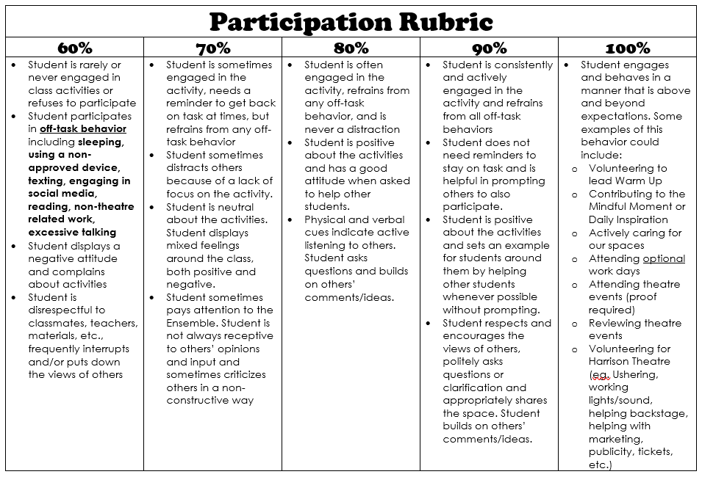

Click here to sign the Syllabus Acknowledgment & Media Release Form

